H.T No
Regulations:
A15


Sreenidhi Institute of Science and Technology
(An Autonomous Institution)
Code No: 5H315 Date: 28-Nov-2018 (FN)

B.Tech II-Year I-Semester External Examination, November - 2018 (Supplementary)
Engineering Mathematics-III (Common to All Except BT)

Time: 3 Hours Max.Marks:75

Note: a) No additional answer sheets will be provided.
b) All sub-parts of a question must be answered at one place only, otherwise it will not be valued.
c) Missing data can be assumed suitably.

Part - A Max.Marks:25

Answer all QUESTIONS.

1. | Briefly explain the Bisection method. | [3M]
2. | Write the Gauss Central Difference Formula. | [3M]
3. | Write the Mathematical formula for Taylor’s series method to find the solution of ODE. | [3M]
4. | Prove that 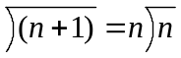 | [3M]
5. | Define limit, continuity and differentiability of a complex function. | [3M]
6. | Give an example for magnification in complex analysis. | [2M]
7. | Write Mathematical formula for Regula Falsi method. | [2M]
8. | Briefly explain the Picard’s Mehtod. | [2M]
9. | State Cauchy-Riemann Equations in Cartesian coordinate system. | [2M]
10. | Write cross ratio when two point are given in complex analysis. | [2M]
Part – B Max.Marks:50
ANSWER ANY FIVE QUESTIONS. EACH QUESTION CARRIES 10 MARKS.

11. | a) | Find a real root of the equation x³ – 4x – 9 = 0 using the bisection method correct to three decimal places | [5M]
 | b) | Evaluate by Trapezoidal rule by taking h = 0.25 | [5M]
12. | a) | Find the Lagrange interpolating polynomial using the following data. x 2.5 3.5  f(x) 6 8 | [5M]
 | b) | Find the value of y at x = 5.4 from the following table | [5M]
  x | 5 | 6 | 9 | 11
  y | 12 | 13 | 14 | 16
13. | a) | Using Euler’s method , find approximate value of y when x = 0.6 of 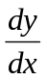 = 1 – 2xy  Given that y = 0 when x = 0 ( take h = 0.2 ) | [5M]
 | b) | Apply 4th order Runge – Kutta method to find an approximate value of y for x = 0.2 in Steps of 0.1 if 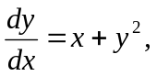 given that y = 1 when x = 0 | [5M]
14. | a) | Evaluate 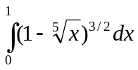 by using Beta function. | [4M]
 | b) | Prove that 4 J₀^{I} + J_{3 = 0.} | [6M]
15. | a) | Determine the analytic function whose real part is u = e^{x} (x cosy – y siny) | [6M]
 | b) | Expand 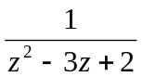 in Laurent’s series in the region 1 < | z | < 2 | [4M]
16. | a) | Find the bilinear transformation which maps z=0, − i, −1 onto w = i, 1, 0 | [5M]
 | b) | Under the transformation w=1/z find the image of circle 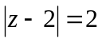. | [5M]
17. | a) | Explain Newton’s Raphson method | [3M]
 | b) | Write the forward difference table for the following data | [3M]
  x | 5 | 6 | 9 | 11
  y | 12 | 13 | 14 | 16
 | c) | Write the Predictor and Corrector formula of Milne’s method | [4M]
18. | a) | 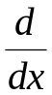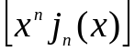 = x^{n} J_{n-1} (x). | [3M]
 | b) | Evaluate using theorem 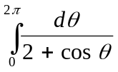. | [4M]
 | c) | Find the image of the curve (the circle) |z – 3|=5 under the mapping w=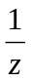 | [3M]

-- 00 -- 00 –

